Weather Data Analysis using Hadoop MapReduce (Temperature Analysis)

1. Objective
The objective of this experiment is to analyze weather temperature data using Hadoop MapReduce and identify the hottest and coldest days from the dataset. Hadoop Streaming is used with Python Mapper and Reducer programs to process large-scale weather data stored in HDFS.

2. Procedure

Step 1: Create Weather Dataset
Create a weather dataset containing Date, City, Maximum Temperature, and Minimum Temperature.

Step 2: Generate Large Dataset
Replicate the dataset multiple times to simulate a large-scale weather dataset.

Step 3: Create Mapper Program
Develop a Python mapper program to extract temperature values from each record and emit key-value pairs.

Step 4: Create Reducer Program
Develop a Python reducer program to find:
- Hottest day based on maximum temperature.
- Coldest day based on minimum temperature.

Step 5: Upload Dataset to HDFS
Create HDFS directories and upload the weather dataset.

Step 6: Execute Hadoop Streaming Job
Run Hadoop Streaming MapReduce jobs using the mapper and reducer scripts.

Step 7: View Results
Display the output stored in HDFS and identify the hottest and coldest days.

3. Source Code

Dataset Creation
cat > weather_data.txt << 'EOF'
2024-01-01,Delhi,12,5
2024-01-02,Delhi,14,6
2024-01-03,Delhi,10,3
2024-01-04,Mumbai,28,20
2024-01-05,Mumbai,30,22
2024-01-06,Bangalore,25,18
2024-01-07,Bangalore,26,19
2024-01-08,Chennai,32,25
2024-01-09,Chennai,33,26
EOF

for i in {1..100}
do
cat weather_data.txt
done > weather_large.txt

Mapper Program (mapper_max_temp.py)
#!/usr/bin/env python3

import sys

for line in sys.stdin:
line = line.strip()

if not line:
continue

parts = line.split(',')

if len(parts) != 4:
continue

try:
date = parts[0]
city = parts[1]
max_temp = float(parts[2])
min_temp = float(parts[3])

print(f"{date}\t{max_temp}")

except ValueError:
continue

Reducer Program for Hottest Day (reducer_max_temp.py)
#!/usr/bin/env python3

import sys

max_temp = float('-inf')
hottest_date = None

for line in sys.stdin:
line = line.strip()

if not line:
continue

date, temp = line.split('\t')
temp = float(temp)

if temp > max_temp:
max_temp = temp
hottest_date = date

if hottest_date is not None:
print(f"Hottest Day: {hottest_date} with {max_temp}°C")

Reducer Program for Coldest Day (reducer_min_temp.py)
#!/usr/bin/env python3

import sys

min_temp = float('inf')
coldest_date = None

for line in sys.stdin:
line = line.strip()

if not line:
continue

date, temp = line.split('\t')
temp = float(temp)

if temp < min_temp:
min_temp = temp
coldest_date = date

if coldest_date is not None:
print(f"Coldest Day: {coldest_date} with {min_temp}°C")

HDFS Commands
hdfs dfs -mkdir -p /user/$USER/weather/input

hdfs dfs -put weather_large.txt /user/$USER/weather/input/

Hadoop Streaming Command for Hottest Day
hadoop jar $HADOOP_HOME/share/hadoop/tools/lib/hadoop-streaming-*.jar \
-input /user/$USER/weather/input/weather_large.txt \
-output /user/$USER/weather/output_max \
-mapper "python3 mapper_max_temp.py" \
-reducer "python3 reducer_max_temp.py" \
-file mapper_max_temp.py \
-file reducer_max_temp.py

View Output
hdfs dfs -cat /user/$USER/weather/output_max/part-00000

Hadoop Streaming Command for Coldest Day
hadoop jar $HADOOP_HOME/share/hadoop/tools/lib/hadoop-streaming-*.jar \
-input /user/$USER/weather/input/weather_large.txt \
-output /user/$USER/weather/output_min \
-mapper "python3 mapper_max_temp.py" \
-reducer "python3 reducer_min_temp.py" \
-file mapper_max_temp.py \
-file reducer_min_temp.py

View Output
hdfs dfs -cat /user/$USER/weather/output_min/part-00000

4. Screenshots
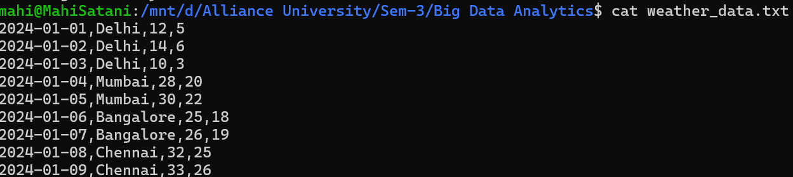
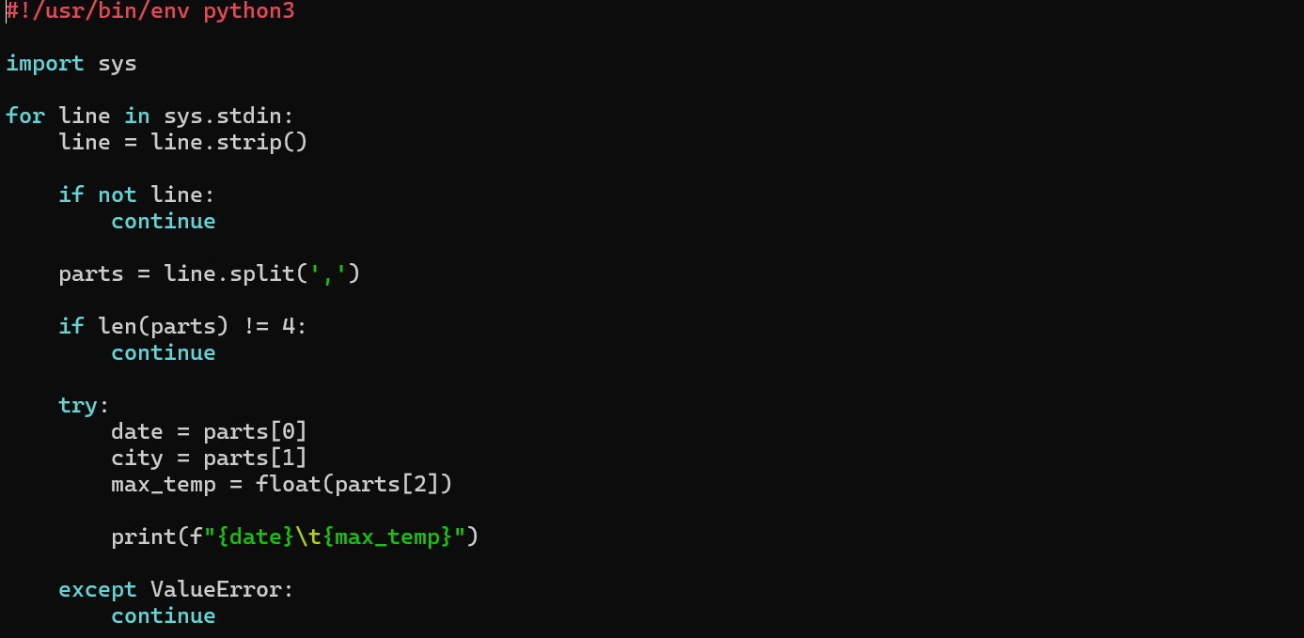
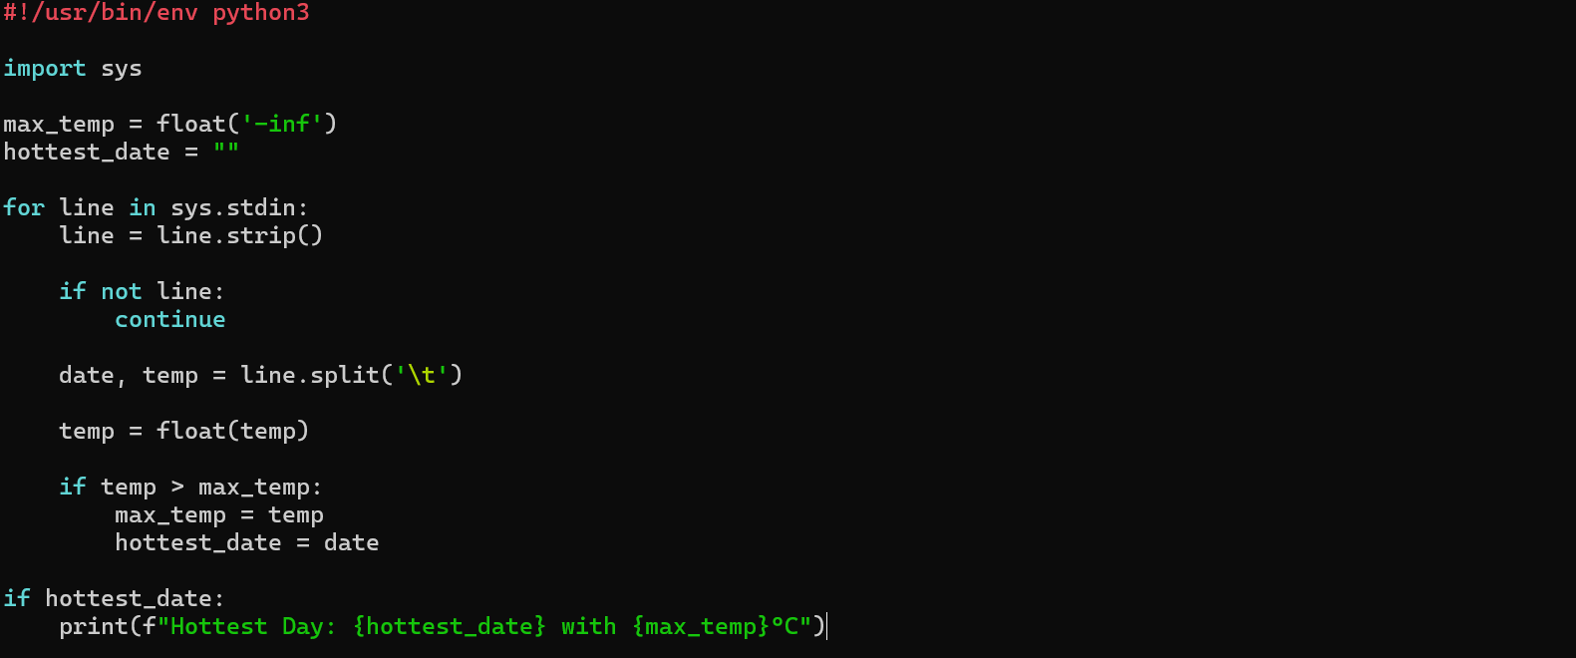
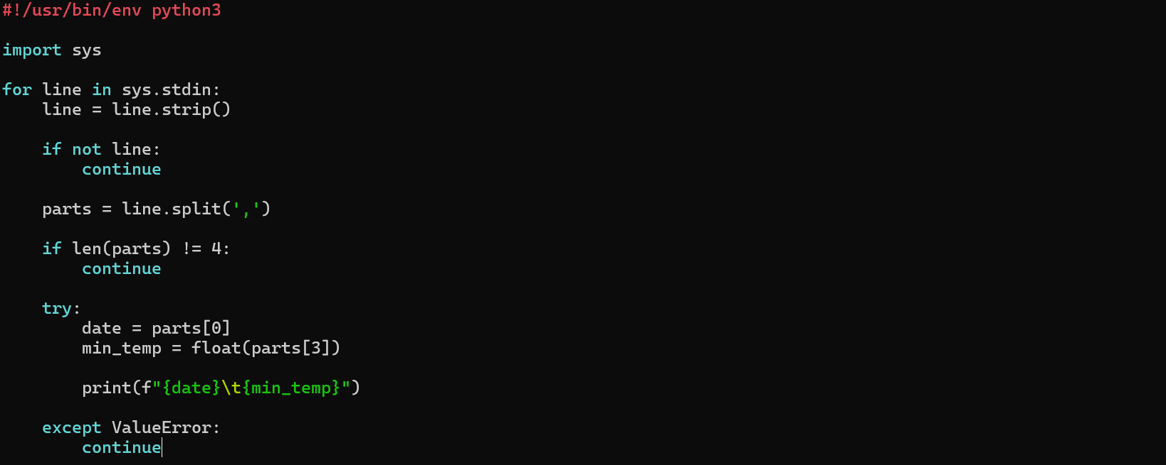
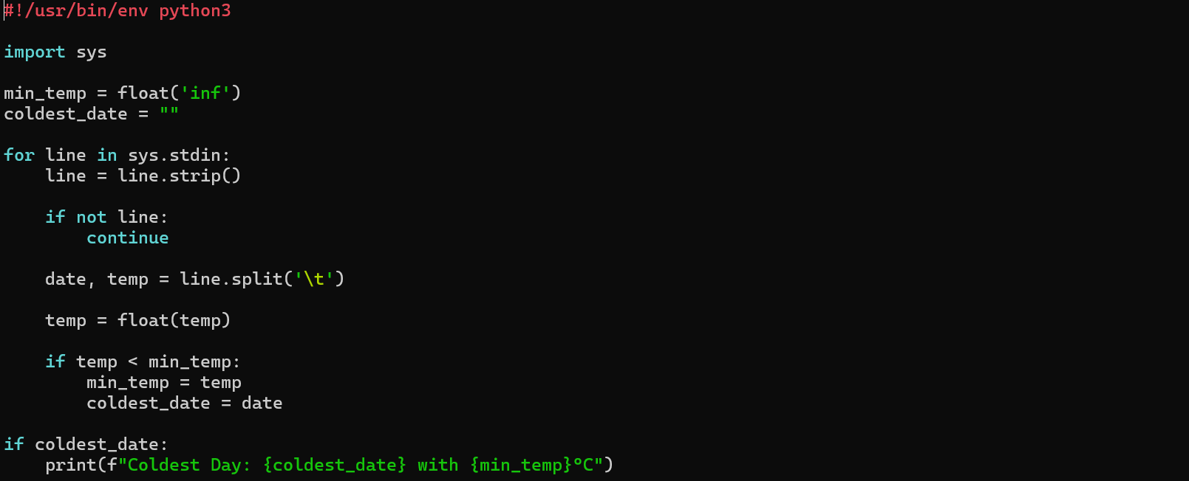

5. Conclusion
The weather temperature dataset was successfully analyzed using Hadoop MapReduce with Python Streaming. Mapper programs extracted temperature information, and Reducer programs identified the hottest and coldest days from the dataset. This experiment demonstrated the effectiveness of Hadoop MapReduce in processing and analyzing large-scale weather data efficiently.

